Machine Learning Engineer Nanodegree

Capstone Project
Online News Popularity

R. Dhanuja

February 24th,2019

I. Definition

PROJECT OVER VIEW:-

The consumption of online news increases day by day due to the wide spread adoption of smartphones and the rise of social networks. For instance, using social media like Twitter and Facebook. For the online news stake holders such as content providers or advertisers, it’s very valuable if the popularity of the news articles can be accurately predicted prior to the publication. This project is based on the online news article popularity. Thus, it is interesting and meaningful to use the machine learning techniques to predict the popularity of online news articles .
In this project, based on the dataset including 39,643 news articles from website Mashable ​UCIWEBISTE​, we will try to find the best classification learning algorithm to accurately predict if a news article will become popular or not prior to publication.

PROBLEM STATEMENT

The main aim of my project is ​to predict the future popularity of news article prior to its publication estimating the number of shares, likes, and comments etc. (features of an
article).​ ​The dataset is publicly available at
https://archive.ics.uci.edu/ml/datasets/Online+News+Popularity#​.​​So my goal is to predict
the online news article popularity. Here I am using classification models s including Logistic Regression, RF, and Adaboost. to find the accuracy of each model and select the best model with high accuracy to predict the popularity. Here the input parameters are training data that we took and the output will be the target label (popular/unpopular) .

The tasks involved in it are:

- Download the data

- Visualizing the data.

- Split the data and train and test which classifier performs good on the dataset based on the evaluation metric we have chosen.

- Choose the best classifier that gives the best accuracy scores.

METRICS
In the data set the class labels (+, -) are very closely balanced. we are using the following metrics.

- Accuracy: Accuracy is direct indication of the proportion of correct classification. It considers both true positives and true negatives with equal weight and it can be computed as
​accuracy = true positives + true negatives/ dataset size | ​(1)
Although the measure of accuracy might be naive when the data class distribution is highly skewed, but it is still an intuitive indication of model’s performance.

- F1-score: F1-score is an unweighted measure for accuracy by taking harmonic mean of precision and recall, which can be computed as

F1 = 2 · precision · recall/ precision + recall (2)

It is a robust measurement since it is independent of data class distribution.

- AUC: The AUC is the area under the ROC (Receiver Operating Characteristics) curve, which is a plot of the True Positive Rate versus the False Positive Rate. AUC value is a good measure of classifier’s discrimination power and it is a more robust measure

For all above three metrics, the higher value of the metric means the better performance of model.

II. Analysis

DATA EXPLORATION

The dataset is downloaded from UCI Machine Learning Repository as https://archive.ics.uci.edu/ml/datasets/Online+News+ Popularity#. The dataset is consisted of 39,643 news articles from an online news website called Mashable collected over 2 years from Jan. 2013 to Jan. 2015. For each instance of the dataset :
Number of Attributes: 61 (58 predictive attributes, 2 non-predictive, 1 goal field)
The dataset has already been initially preprocessed. For examples, the categorical features like the published day of the week and article category have been transformed by one-hot encoding scheme, and the skewed feature like number of words in the article has been log transformed.
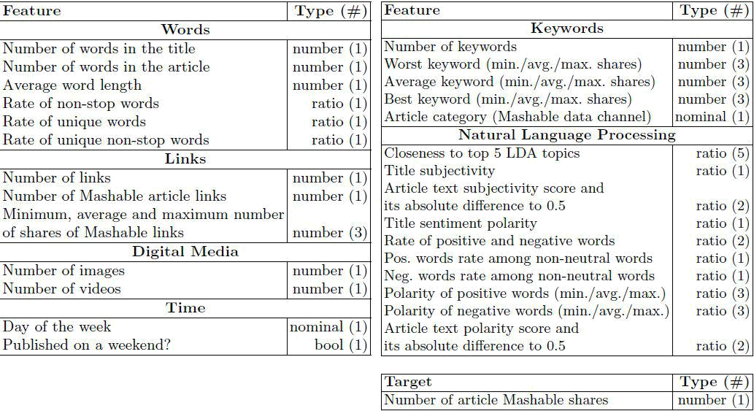

Figure 1: List of predictive attributes of dataset

we show the statistics of the target attribute ”shares” to determine the appropriate threshold for number of shares to discriminate the news to be popular or unpopular. ​in​ Fig. 2, and we find the median of target attribute is 1,400, thus it is reasonable if we take 1,400 as a threshold. Then we can use this threshold to convert the continuous number target attribute into a boolean label.
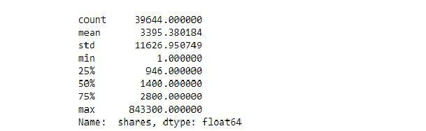

Figure 2: Statistics of target attribute ”shares”
By observing various features, I think there are several relevant features like day of the week and article category. In Fig. 3, the count of popular/unpopular news over different day of the week is plotted.
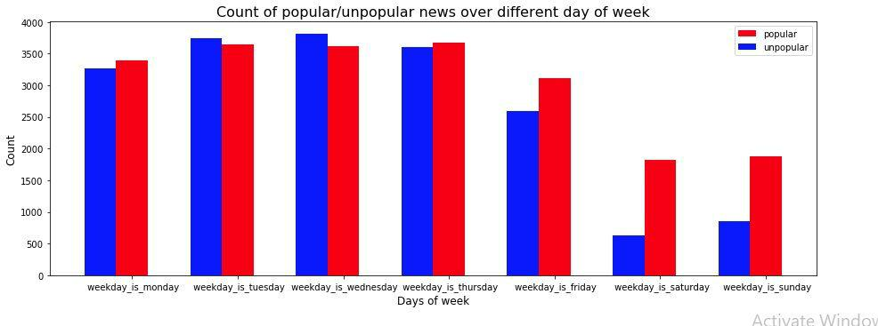

Figure 3: Count of popular/unpopular news over different day of week.

We can clearly find that the articles published over the weekends has larger potential to be popular. It makes sense because it is very likely that people will spend more time online browsing the news over the weekends

In Fig. 4, the count of popular/unpopular news over different article category is plotted.
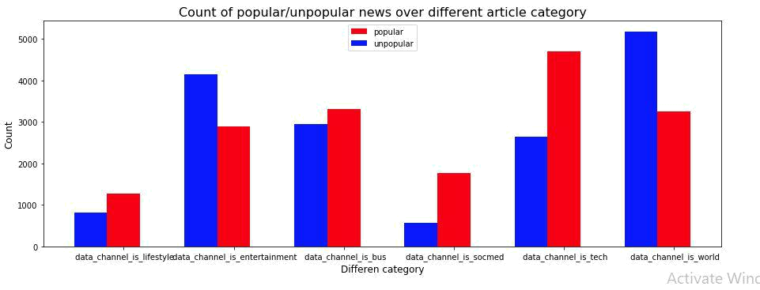

Figure 4: Count of popular/unpopular news over different article category.

We can observer that in category of technology (”data channel is tech”) and social media (”data channel is socmed”), the proportion of popular news is much larger the unpopular ones, and in category of world (”data channel is world”) and entertainment (”data channel is entertainment”), the proportion of unpopular news is larger the popular ones. This might reflects that the readers of Mashable prefer the channel of technology and social media much over the channel of world and entertainment.

Next, we do the principle component analysis (PCA) to visualize the data. As shown in Fig. 5, we project the data point onto first 2 and 3 principle components, respectively.
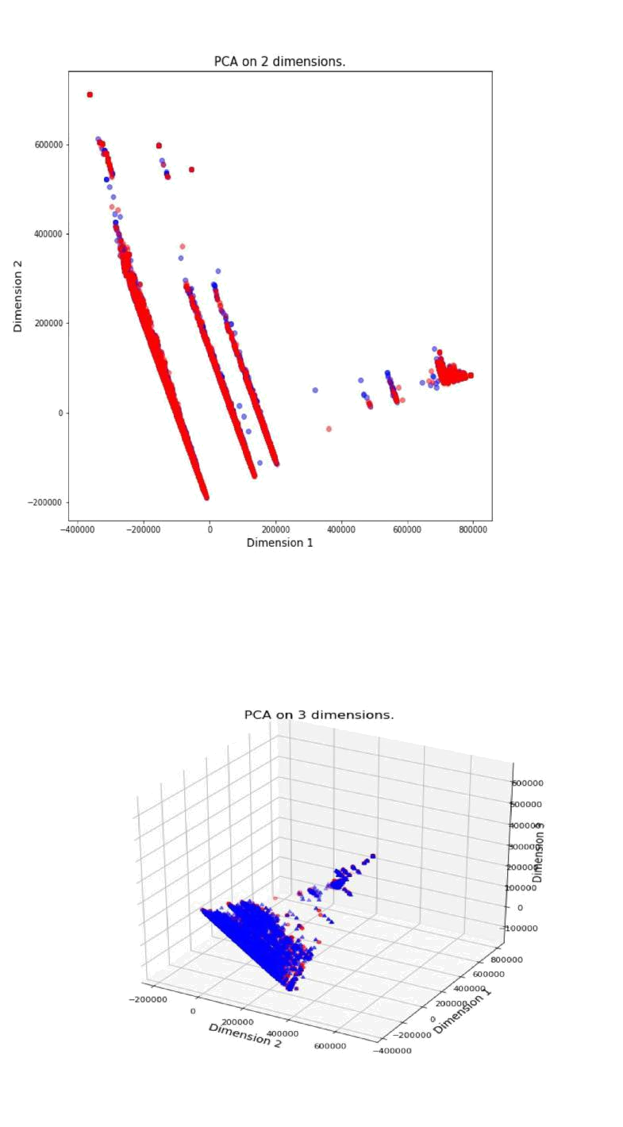

Figure 5: (a) Data projected on first 2 principle components (b) Data projected on first 3

principle components. Red: popular; Blue: unpopular

It is clear that the dataset is not linearly separable in PCA space.

Algorithms and Technique​s

Since we formulate this problem as a binary classification problem three classification learning algorithms including Logistic Regression, RF,and Adaboost will be implemented
LOGISTIC REGRESSION:

Logistic Regression is a Machine Learning classification algorithm that is used to predict

the probability of a categorical dependent variable. In logistic regression, the dependent

variable is a binary variable that contains data coded as 1 (yes, success, etc.) or 0 (no,

failure, etc.). In other words, the logistic regression model predicts P(Y=1) as a function

of X.

Advantages:

Because of its efficient and straightforward nature, doesn't require high computation

power, easy to implement, easily interpretable, used widely by data analyst and

scientist. Also, it doesn't require scaling of features. Logistic regression provides a

probability score for observations.

Disadvantages:

Logistic regression is not able to handle a large number of categorical features /variables. It is vulnerable to over fitting. Also, can't solve the non-linear problem with the logistic regression that is why it requires a transformation of non-linear features. Logistic regression will not perform well with independent variables that are not correlated to the target variable and are very similar or correlated to each other.

Parameters:

Class sklearn.linear_model.LogisticRegression (penalty=’l2’, dual=False, tol=0.0001, C=1.0, fit_intercept=True, intercept_scaling=1, class_weight=None, random_state=None, solver=’warn’, max_iter=100, multi_class=’warn’, verbose=0, warm_start=False, n_jobs=None)

RANDOM FOREST:

Tree models are known to be high variance, low bias models. In consequence, they are prone to overfit the training data. This is catchy if we recapitulate what a tree model does if we do not prune it or introduce early stopping criteria like a minimum number of instances per leaf node. Well, it tries to split the data along the features until the instances are pure regarding the value of the target feature, there are no data left, or there are no features left to spit the dataset on. If one of the above holds true, we grow a leaf node.The consequence is that the tree model is grown to the maximal depth and there with tries to reshape the training data as precise as possible which can easily lead to over fitting. Another drawback of classical tree models like the (ID3 or CART) is that they are relatively unstable. This instability can lead to the situation that a small change in the composition of the dataset leads to a completely different tree model. Parameters:

Class sklearn.ensemble.RandomForestClassifier (n_estimators=’warn’, criterion=’gini’, max_depth=None, min_samples_split=2, min_samples_leaf=1,
min_weight_fraction_leaf=0.0, max_features=’auto’, max_leaf_nodes=None,

min_impurity_decrease=0.0, min_impurity_split=None, bootstrap=True,

oob_score=False, n_jobs=None, random_state=None, verbose=0, warm_start=False,

class_weight=None

Advantages:

1.Reduction in over fitting: by averaging several trees, there is a significantly lower risk of over fitting.

2.Less variance: By using multiple trees, you reduce the chance of stumbling across a

classifier that doesn’t perform well because of the relationship between the train and

test data.

Disadvantages :

1. It takes more time to train samples.

ADABOOST:

AdaBoost classifier is an ensemble classifier that begins by fitting a classifier on the original dataset and then fits additional copies of the classifier on the same dataset but where the weights of incorrectly classified instances are adjusted such that subsequent classifiers focus more on difficult cases. sklearn provides a function called AdaBoostClassifier(). One tunable parameters is ”n estimators”, which is the maximum number of estimators at which boosting is terminated. Another is ”learning rate”, which means the contribution of each classifier shrinks by the value of ”learning rate”. There is a trade-off between ”n estimators” and ”learning rate”. The boosting can help in learning complex non-linear hypothesis which is necessary because the dataset here is not linearly separable.In this project, we will first implement all three algorithms with the default hyperparameter settings, then we will use grid search method to refine the hyperparameters and thereby improve the model’s performance. For logistic regression, we will tune the hyperparameter”C”, which is the inverse of regularization strength. ”C” is basically used for control overfitting. A smaller ”C” means higher regularization over the model parameters, thus smaller ”C” will decrease the magnitude of model parameters to prevent over-fitting. For RF, we will tune hyperparameter ”n estimators”, which is the maximum number of trees you can build before taking the maximum voting or averages of predictions. Higher number of trees can give better performance but makes code running slower. For Adaboost, the default base estimator is decision tree classifier. Similar to RF, hyperparameter ”n estimators” represents the maximum number of trees you can build before termination. Higher numberof trees may lead to better performance but will decrease the model running speed. The trade-off between ”n estimators” and ”learning rate” is as follows: a larger ”learning rate” typically means smaller ”n estimators” in Adaboost but might lead to over-fitting, while a smaller
”learning rate” typically means larger ”n estimators” and it will control over-fitting but slow down the running speed.

Benchmark

Benchmark model is a model which we will take as reference and achieve the best result than the benchmark model .In my project. Here Accuracy score will be compareD between the different classification models(Adaboost,Random Forest,Logistic regression) and select the best one.

III. Methodology

Data Pre-processing:

As mentioned in Section 2.1, some data preprocessing works have been done by the data’s donator. The categorical features like the published day of the week and article category have been transformed by one-hot encoding scheme, and the skewed feature like number of words in the article has been log-transformed. I further preprocess the dataset by normalizing the numerical feature to the interval [0, 1] such that each feature is treated equally when applying supervised learning.

Since there are 58 features in the dataset, it is reasonable to conduct a feature selection to reduce the data noise and increase the algorithm running speed. One effective way is using recursive feature elimination with cross validation (RFECV) to automatically select the most significant features for certain classifier. sklearn provides a function called REFCV() that can help us.

Firstly, we run RFECV with a logistic regression estimator. The cross validation score versus the number of feature selected
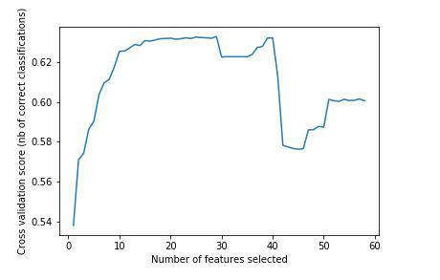

Figure 6: The cross validation score versus the number of feature selected using RFECV for logistic regression estimator.
From the figure, we can find there is drop of score when number of features is 29. Thus RFECV algorithm select 29 most relevant features from 58 original features as shown in below figure.
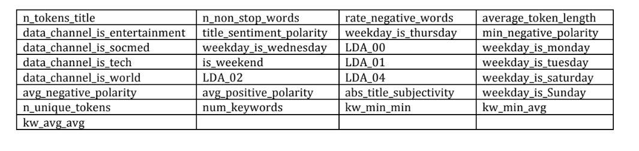

Next ,we run with Adaboost
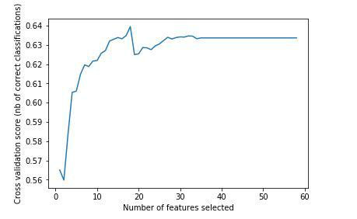

From the figure, we can find there is a peak when number of features is 18. Thus RFECV algorithm select 18 most relevant features from 58 original features.
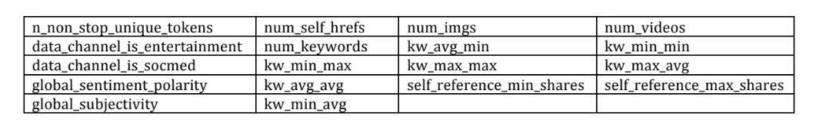

Lastly, we run with Random forest
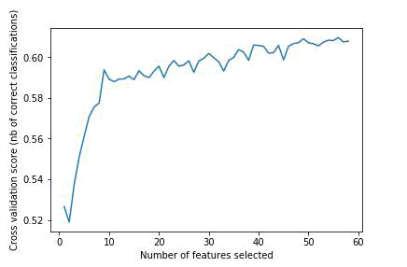

We find that REFCV selects 56 features(almost the full features) for RF.The two features that are not selected are[ n non stop words’, ’ data channel is lifestyle’].

Implementation:

Before algorithm implementation, for each algorithm, I also randomly split dataset with its own selected features into training set (70%) and testing set (30%). The logistic regression,RF and Adaboost are implemented by the sklearn function LogisticRegression(), RandomForestClassifier() and AdaBoostClassifier(), respectively. At this stage, I will first use the default setting for model hyperparameters.

I run the three classification algorithms and their performance is as

classsifier | acuracy | F1score | AUC
adaboost | ​0.6432 | 0.67598 | 0.6393
Logistic regression | 0.6329 | 0.67153 | 0.6280
Random forest. | 0.6251 | 0.6282 | 0.627

Adaboost performs best in all three metrics, RF performs better than logistic regression in AUC while logistic regression performs better than RF in accuracy and F1-score. As for the training and testing speed, logistic regression is much faster than the other two.RF runs fast than Adaboost.

Refinement:

In this part, I will use the grid search method for each of the three classifiers to refine their hyperparameters.After running the grid the search, the refined hyper parameters
are obtained.

regression - {”C”: 0.5};

RF-{”n estimators”: 500};

Adaboost-{”n estimators”: 300, ”learning rate”: 0.5}.

Now we run the three classifiers with refined parameters, the three metrics are summarized.

classsifier | acuracy | f1score | AUC
adaboost | ​0.6508 | 0.6830 | 0.6470
Logistic regression | 0.6329 | 0.6714 | 0.6281
Random forest. | 0.6678 | 0.6991 | 0.6639

IV. Result

Model evaluation and validation

After initial implementation and further refinement for the three classifiers, we find the best performance is obtained by the RF classifier with 500 trees in the forest. The best obtained metrics of RF are accuracy 0.6769, F1-score 0.7073 and AUC 0.6734.To test the robustness of the model, we change split ratio of training/testing set from 0.30 to

0.15, and then run the three classified with the same refined hyperparameters. Now the metrics are

classsifier | acuracy | f1score | AUC
adaboost | ​0.6494 | 0.6818 | 0.64576
Logistic regression | 0.6324 | 0.6689 | 0.62825
Random forest. | 0.6742 | 0.7052 | 0.67055

Justification:

The best performance is also given by RF model, which achieves 66% of accuracy ,69% of F1 score and AUC of 66%.So we can say the obtained model achieves a comparable performance than Logistic regression, adaboost and it is significant enough to solve the popular news classification problem.
V. Conclusion

FREE FORM VISUALIZATION:

In this part, the performance of three classifiers with refined hyperparameters is finally displayed . As shown in the visualization, the training and testing time of RF is greatly increased since 500 trees are used in the forest, but it helps RF achieve the best performance in terms ACCURACY F1 SCORE and AUC
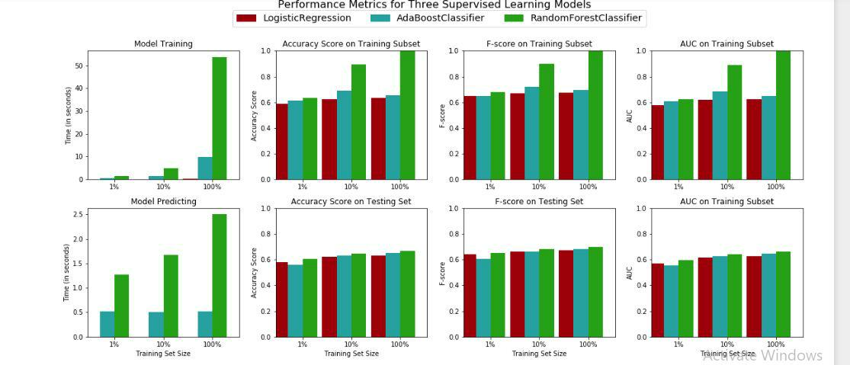

REFLECTION:

The interesting aspect of this project is from the feature selection part. I assume the day of the week and article category could be the relevant features by analysis and visualization. And later in the part of feature selection by RFECV, my guess is verified, which also shows the effectiveness of RFECV. The difficult part of the project is

- how to define a problem, collect the corresponding data and engineer/select the relevantfeatures;

- how to choose appropriate learning algorithm and refine the hyperparameters. Since the obtained model achieve a fairly good performance, I think RF model with a refined hyperparameter should be used in a general setting to solve these types of problems.

IMPROVEMENT:
the improvement can be done as follows:

1.engineer and add more relevant features to the original dataset dataset since RF has a strong learning capability and a rich dataset might improve its prediction performance 2.we could use all the words in an article as additional features, and then try the classifier such as Naive Bayes to see if it can achieve a better performance.

